STAT641 regression analysis homework #1

Part I

1. E. All of the above statements are true
2. B. y decreases by 3 when x increases by 4
3. E. All of the above statements are true
4. A. least squares method
5. B. the observed values of the response variable y and the estimated values $\hat{y}$
6. C. 1.600
7. D. 9.76
8. E. All of the above statements are true
9. C. 0.667
10. C. 0.970
11. A. The coefficient of determination, denoted by R2 is interpreted as the proportion of observed y variation that cannot be explained by the simple linear regression model.
12. B. $\sqrt{SSE/(n-2)}$
13. Either $t≥2.878 or t≤-2.878$
14. B. .02

Part II

1. a. $\hat{y}=21.79-0.070x_{8}$

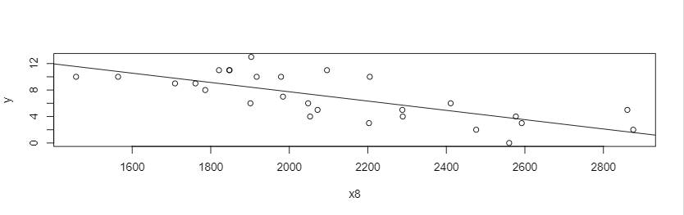

b. $p=7.38e-06<0.05$; We reject the null hypothesis, there is evidence that the number of games won is related to the number of yards gained by rushing opponents.

c. $-0.0096≤β_{1}≤-0.0044$

d. 0.54

e. $6.77≤\hat{y_{2000}}≤8.71$

1. a. $\hat{y}=607.10-21.40x_{4}$

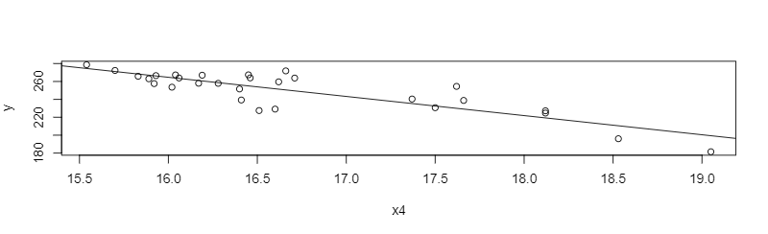

b. $p=5.94e-09<0.05$; We reject the null hypothesis, there is evidence that the total heat flux is related to the radial deflection of the deflected rays.

c. $-28.51≤β_{1}≤-14.29$

d. 0.72

e. $249.15≤\hat{y_{16.5}}≤258.78$

1. a. $\hat{y}=77.863+11.801x$

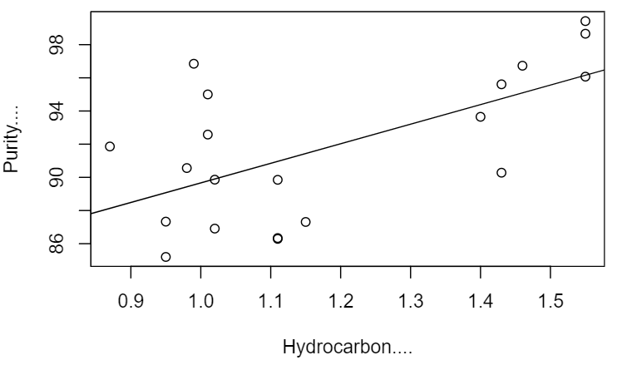

b. $p=0.0033<0.05$; We reject the null hypothesis, there is evidence that the purity of oxygen is related to the percentage of hydrocarbons in the main condenser.

c. 0.39

d. $4.48≤β_{1}≤19.12$

e. $87.51≤\hat{y_{1.00}}≤91.82$

1. a.

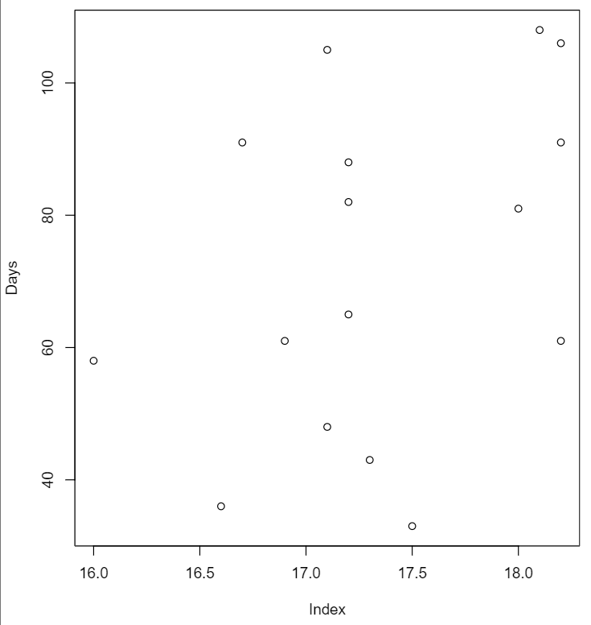

b. $\hat{y}=-192.98+15.296x$

c. $p=0.13>0.05$; We fail to reject the null hypothesis, there is not enough evidence to conclude that the purity of oxygen is related to the percentage of hydrocarbons in the main condenser.

d.

